**DAILY ONLINE ACTIVITIES SUMMARY**

|  |  |  |  |  |  |  |  |  |
| --- | --- | --- | --- | --- | --- | --- | --- | --- |
| **Date:** | **22-05-2020** | | | | | **Name:** | **Sathvik R Shetty** | |
| **Sem & Sec** | **VI B** | | | | | **USN:** | **4AL17CS089** | |
| **Online Test Summary** | | | | | | | | |
| **Subject** | | **OR IA Test** | | | | | | |
| **Max. Marks** | | **30** | | **Score** | | | **30** | |
| **Certification Course Summary** | | | | | | | | |
| **Course** | **Web Development with Python and JavaScript** | | | | | | | |
| **Certificate Provider** | | | **Harvard University** | | **Duration** | | | **12week** |
| **Coding Challenges** | | | | | | | | |
| **Problem Statement:**  1. Python program to print all Prime numbers in an Interval. Given two positive integers start and end. The task is to write a Python program to print all Prime numbers in an Interval.  2. Python Program to find sum of array. Given an array of integers (take input from keyboard), find sum of its elements | | | | | | | | |
| **Status: Completed** | | | | | | | | |
| **Uploaded the report in GitHub** | | | | | **Yes** | | | |
| **If yes Repository name** | | | | | <https://github.com/sathvikshetty22/Online-Coding> | | | |
| **Uploaded the report in slack** | | | | | **Yes** | | | |

**Online test Detail:**

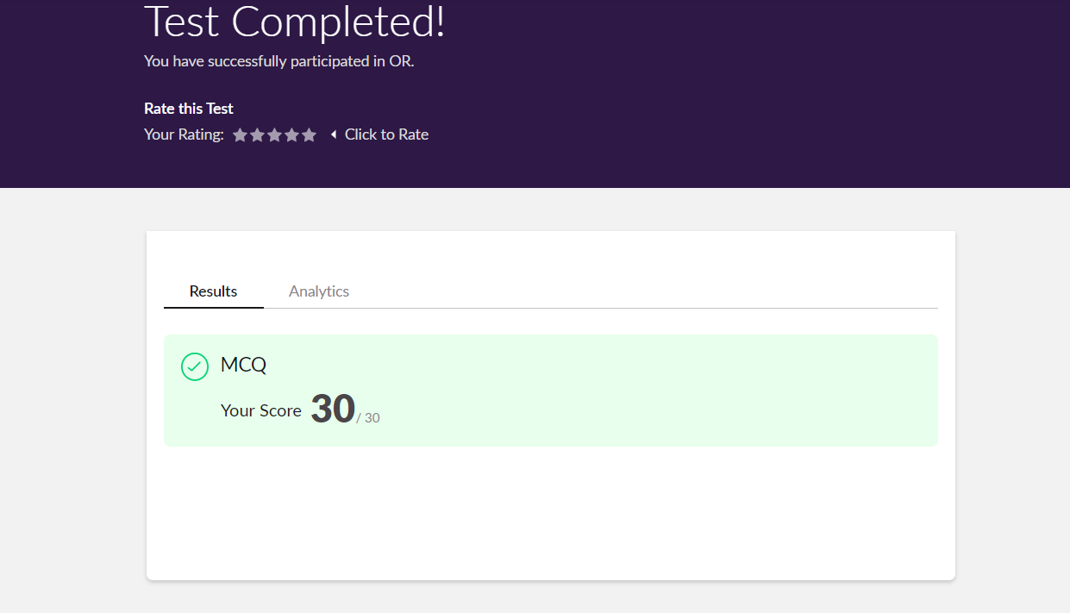

**Online Certification Details**

Lesson-5

* 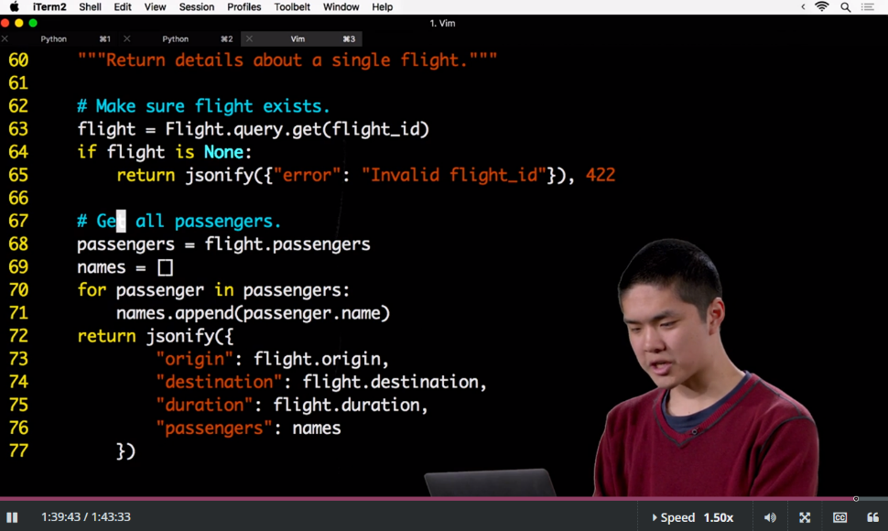ORMs
* APIs

**Coding Challenge Details**

1. Python program to print all Prime numbers in an Interval. Given two positive integer start and end. The task is to write a Python program to print all Prime numbers in an Interval.

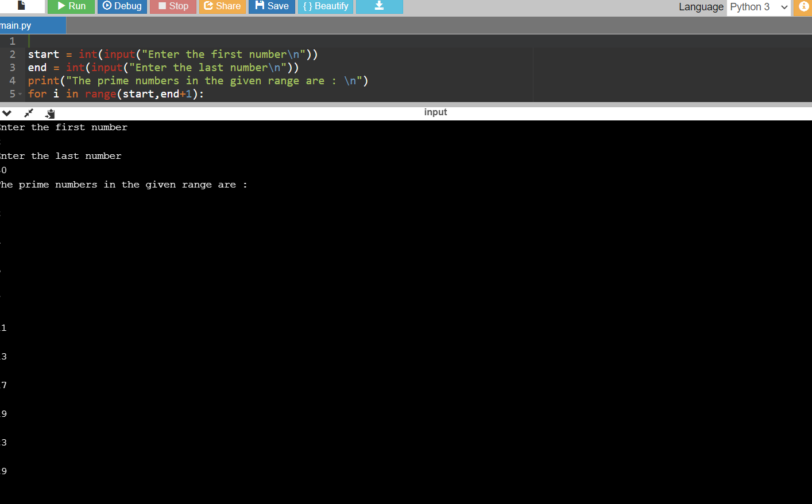

2. Python Program to find sum of array. Given an array of integers(take input from #keyboard), find sum of its elements.

